O R G A N I S A T I O N A L

Title: Comments, Concerns, Complaints and Compliments

Doc. ref. no.: ORG13 | Issue/version: 3.0 | Pages: 11
Status: Final | Date signed off by trustees: 2023-10-10 | Next review: 2026-08-10
Target audience: All FfT staff and volunteers

Introduction
  - This policy explains the high value Freedom from Torture (FfT) places on feedback regarding our services and sets out a procedure for handling positive and negative feedback and complaints. For this policy, the term feedback includes positive and negative feedback, comments, concerns, and compliments.

- Scope of Policy
  - Anyone can give feedback or make a complaint about FfT’s services. This is most likely to be clients in receipt of direct services, but we also welcome feedback from carers, family members, colleagues at partner organisations, supporters, and members of the public.

  - This covers feedback or a complaint made by a user of all FfT’s services. The term services covers CEO, Communications and Fundraising, Clinical, Finance, and Survivor Empowerment and Policy and Advocacy Directorates. Note that a person does not have to state explicitly that they are making a complaint for us to recognise it as such and for it to be dealt with under this policy (see 4.6 below)

  - This policy & procedure should also be used to handle feedback and complaints received from any external organisation or individual regarding the delivery of FfT services.

  - This policy aims to set out clearly how staff are to support service users to make use of this procedure where appropriate.

  - This policy does not apply to complaints from staff. Staff complaints are dealt with under the Grievance policy and procedure.

  - Complaints from supporters should be directed to the fundraising directorate in the first instance, here.

Aim
  - To set out the process of making feedback and complaints and ensure there is a timely, fair, and consistent approach.
  - To ensure feedback from survivors of torture drives the improvement of quality at FfT and enhances the client’s experience.
  - To recognise that FfT does not always get things right and is keen to hear when things have not gone well to rectify, learn from experience and improve services.
  - To value positive feedback so that FfT can build on good practice.
  - To ensure that there is a learning culture embedded into the processes and that feedback and complaints are regularly reviewed to facilitate continuous learning and quality improvement across the organisation.

Procedure
Feedback is actively sought from clients and collected in a variety of ways including client surveys and client feedback forms. Complaints or feedback can be made/given verbally (including via telephone) or in writing (including email and website contact form) to any member of staff (including volunteers).
  - FfT will ensure that clients are aware that they have a right to feedback and or submit a complaint.
  - FfT will provide clients with clear information on how to feedback or complain.
  - FfT will provide clients with interpreters as required.
  - FfT will publish how to give feedback or make a complaint on the website for public access.
  - Providing feedback or sharing a complaint will not adversely affect the care the client receives from FfT. Nor will any record of the feedback or complaint, be kept in an individual’s clinical record.
  - The person giving the feedback or complaint does not necessarily need to state explicitly that they are making a complaint; if feedback is received that shows dissatisfaction, unhappiness, or concern, it should be recorded and treated as a complaint.
  - The Quality Improvement Team (QI team) will review all forms of feedback and complaints and ensure that they are dealt with in a timely, fair, and consistent approach. This team will include input from the SUE directorate.
  - The QI team will ensure there is a system in place to ensure lessons learned are identified from feedback and complaints and disseminated, resulting in recommendations and action plans to improve quality and reduce risk.
  - If the person making the feedback or giving the complaint is a client or ex-client and does not feel able for any reason to speak to staff or is unhappy with the action taken in response then they can contact the QI team directly, who will identify someone within this team (the Client Advice and Liaison Link) to provide a point of contact for clients with feedback or concerns. This person will help the client understand their rights, provide a listening space, information, advice, and support to hear their feedback and concerns, provide practical advice and support about the formal complaint process and resolve concerns in a timely manner. This person will also create links with local and national organisations who can provide further support.
  - Note that any complaint regarding a medical doctor must also be reported to our Responsible Officer (RO), who is responsible for clinical governance processes relating to the conduct and performance of doctors at Freedom from Torture. Depending on the nature of the complaint, the RO may need to initiate a further investigation, if there are concerns about the doctor’s fitness to practice.

Complaints: Stage 1
- The staff member receiving the complaint will acknowledge it, log it immediately (see Complaints/comments log, Appendix 2) and inform their manager and the QI team within one working day who will advise on Stage 1 or Stage 2 process.
- FfT will respond in a timely manner (within three working days) to the person raising the concern or complaint, verbally or in writing to acknowledge the concern or complaint and agree a response process either locally or by the QI team.
- Usually, informal complaints can be dealt with and resolved locally between the person with the concern, the staff, their line manager and where requested the Client Advice and Liaison Link.
- A record of the outcome, how resolution was achieved, action points taken and the length of time for resolution should be sent to the QI team. Lessons learned will be identified and disseminated, resulting in recommendations and action plans to improve quality and reduce risk.
- The QI team is responsible for identifying lessons learned, creating action plans, and implementing to improve quality and client experience and to reduce risk.
- Stage 1 complaints will have formal resolution within 15 working days of receipt of the concern or complaint.

Complaints: Stage 2
- A stage 2 complaint can be made if the person raising the concern or complaint is not satisfied with the outcome of the stage 1 complaint process OR if the matter is serious enough to warrant a more formal response.
- Examples of more serious types of complaints warranting a stage 2 investigation include allegations of inappropriate conduct by staff towards clients, allegations of staff breach of professional and ethical guidelines or breach of internal clinical policies. This list is not exhaustive.
- For complaints from clients, FfT must communicate directly with the client, and invite them to talk or meet face to face (according to their preference) with the investigating manager to explain their complaint.
- Stage 2 complaints team will meet weekly to ensure rapid responses, learning and reporting. The team will comprise of the manager of the team who received the complaint and the QI team, who are to inform and where needed involve the Director (and Associate Director if applicable) of that service area. For example, within clinical services, all stage 2 complaints should go to the Head of Clinical Services for the relevant centre and Associate Director of Clinical Services. The National Director of Clinical Services should also be informed of any serious complaints involving any clinical staff. A similar process will apply when the complaint involves staff from other Directorates (Fundraising and Communications, CEO, Finance, Survivor Empowerment and Policy & Advocacy directorates).
- Stage 2 complaints will have a target resolution time of less than 20 working days, with an upper limit of 25 working days, and the response must be put in writing to the person raising the concern or complaint. If a response will take longer than this for whatever reason, the reasons must be given to the person giving the feedback or complaint in writing, along with a new target resolution deadline.
- The response will be reviewed to ensure clarity and ease to comprehend, and learnings and actions will be communicated.
- The Head of CEO Office or CEO will sign off the response to Stage 2 complaints to assure the person making the complaint of the importance placed on the process of resolving, rectifying, and learning from concerns and complaints.

Appeal
  - If the person giving the feedback or complaint is still dissatisfied with the outcome of the complaint at stage 2, an appeal can be lodged with the QI team or CEO office.
  - The QI team or CEO office will investigate and send a formal response within 15 working days.
  - Final appeals can be lodged with the CEO. This may involve arranging a hearing of the complaint (within 20 working days) and then issuing a response following the hearing (within 10 days).

Escalation beyond Freedom from Torture

If the person giving the feedback or complaint is still dissatisfied following exhaustion of the internal FfT complaints procedure set out above, they may take their complaint to the relevant regulatory body.

For psychological therapists:
  - United Kingdom Council for Psychotherapy psychotherapy.org.uk/16/information/complaints
  - British Association for Counselling & Psychotherapy bacp.co.uk/prof_conduct/Downloadable_Documents.php
  - British Psychoanalytic Council bpc.org.uk/about-us/complaints/how-complain

For psychologists, physiotherapists, occupational therapists, art therapists, & social workers:
  - Health & Care Professions Council hpc-uk.org

For legal advisors:
  - The Legal Ombudsman (England & Wales) legalombudsman.org.uk/helping-the-public/legal/ OR
  - The Scottish Legal Complaints Commission (Scotland) http://www.scottishlegalcomplaints.org.uk/making-a-complaint.aspx

Concerns must be referred to the Legal Ombudsman within six months of the final response from Freedom from Torture following application of this complaints procedure. From 1 April 2023, the Legal Ombudsman will expect complaints to be made to them within one year of the date of the act or failure to act that is of concern, or within one year of an individual realising there was a problem with the service received.

See also:
  - The Law Society (England & Wales) lawsociety.org.uk
  - The Law Society of Scotland lawscot.org.uk/
  - The Bar Council (England & Wales) barcouncil.org.uk
  - The Faculty of Advocates (Scotland) advocates.org.uk

For doctors in healthcare organisations:
  - The General Medical Council gmc-uk.org/concerns/making_a_complaint/faqs.asp?WT.ac=MCLC140122
  - The Care Quality Commission cqc.org.uk
  - Healthcare Improvement Scotland healthcareimprovementscotland.org

Responsibilities

Trustees
    - The Performance, Standards and Effectiveness Committee is responsible for monitoring themes from feedback and complaints based on reporting from our QI team and providing suggestions for systemic improvements based on patterns and lessons learned.
    - The Board of trustees is responsible for reviewing and approving this policy every three years based on scrutiny and recommendations from the Performance, Standards and Effectiveness Committee.

  - Senior Management Team
    - The CEO, National Director of Clinical Services and Director of Survivor Empowerment must ensure that processes are in place to help clients understand the value FfT places on feedback of any kind – including comments, concerns, complaints, and compliments – and how to use the procedures set out in this policy. As a minimum, this information must be included in written and verbal service inductions for clients, FfT service user handbook and in introductory sessions for our service user engagement programme.
    - The CEO, National Director of Clinical Services, Director of Survivor Empowerment are responsible for ensuring that lessons from complaints are rolled into service improvement, with support from FfT’s QI team.

  - QI team
    - The QI team is responsible for monitoring, record-keeping, providing support to managers investigating complaints, ensuring FfT has the right processes in place to support learning from complaints and implementation of improvements, analysing themes from complaints and reporting to the Clinical Secretariat, Senior Management Team, and trustees on complaints. They are responsible for identifying lessons learned and creating action plans to improve quality and reduce risk. These lessons are to be shared and local and national events.

  - Responsible Officer
    - The Responsible Officer is responsible for monitoring and ensuring follow up to complaints involving medical doctors at Freedom from Torture.

  - Clinical Secretariat
    - The Clinical Secretariat has primary responsibility for considering themes from complaints and feedback as a basis for continuous service improvement and ensuring decisions in this regard are implemented and communicated to the Senior Management Team.

  - Whistleblowing officer(s)
    - Our whistleblowing officer(s) are responsible for handling any complaints that reach this level of severity, in line with our whistleblowing policy.

  - Other Managers
    - Service managers are responsible for ensuring that frontline staff are familiar with this policy and receive all the necessary support to actively encourage feedback from clients, referrers and other stakeholders and comply with the procedures, including good record-keeping, communication of outcomes to the person giving the feedback or complaint and implementation of lessons learned.
    - Managers are responsible for overseeing compliance by their staff with this policy, including in relation to timeframes, record-keeping, communication with the person giving the feedback or complaint and implementation of lessons learned.
    - The website manager is responsible for ensuring that information about this policy and procedure is easily accessible via Freedom from Torture’s website.

  - Staff
    - Staff in clinical services and our Service User Engagement team are responsible for promoting this policy and procedure to clients in a way that actively encourages feedback – including suggestions, concerns, and complaints – and reassures clients that they will face no victimisation or disadvantage for using this process.
    - All staff must be familiar with this policy, able to signpost clients and other stakeholders to it and answer any questions about the procedures set out in this policy.
    - Staff are responsible for complying with this policy and for seeking any necessary support in operating it from their manager or our QI team.

Equality & Diversity Impact Assessment
  - FfT will ensure that all complaints are dealt with based on the complaint and not the person making the complaint. Staff and volunteers will be sensitive to power imbalances and cultural differences and will support all clients to make use of this procedure, including those least culturally likely to do so.
  - The demographic data of the people who gave feedback or made a complaint will be collected and analysed (wherever possible).

Monitoring & record keeping

Records of all complaints and suggestions will be kept by the appropriate manager, and copies sent to our QI team.

The number, type and management of suggestions and complaints will be monitored through the QI team review process, as well as through quarterly monitoring of complaints submitted to the QI team. This team produces a quarterly report that goes to the Clinical Secretariat, the Senior Management Team and the Performance, Standards and Effectiveness Committee of our Board of trustees.

Copies of all correspondence sent to clients during the investigation process and any materials related to the complaint must be kept in a secure place by the team/centre manager.

All services must keep accurate logs of any complaint and logs must include the following information:
- The date the complaint was received.
- Details of person giving the feedback or complaint (incl MFID where applicable)
- Date of response
- The outcome – resolved or unresolved

Procedures that strongly impact.

- ORG01 - Whistleblowing
- CSP03 - Internal Quality Assurance Reviews
- ORG08 - Confidentiality & Data Protection
- ORG03 - Safeguarding Adults
- ORG04 - Safeguarding Children
- CSP02 - Professional Boundaries
- CSP06 – Managing Incidents
- Process for the investigation of competence, conduct, health and fitness to practice concerns relating to Freedom from Torture doctors

Supporting documents
ORG13-A1 - Complaints log for managers
ORG13-A2 - Comments leaflet

Current document
SU Consultation: (Method and date) | -
Staff Consultation: (Method and date) | -
Reviewed by HR (date): | N/A | Training in place (where required): | Yes | No | n/a
Reviewed by Responsible Office (date): | 2023-09-12 | Action plan in place to address –ve impact(s) | yes | no | n/a
E&D impact assessment (date): | 2023-07-22 | Financial resources in place (where required) | Yes | No | n/a
Reviewed by Finance (date): | 2023-07-22 | H&S requirements in place (where required): | Yes | No | n/a
Reviewed by Facilities Manager (H&S) (date): | N/A | Monitoring requirements in place: | Yes | No | n/a
Reviewed by QA Manager (date): | 2023-03-10
Reviewed by SMT | 2023-07-22
Reviewed by Board of trustees | 2023-10-10
Date Intranet updated: | 2023-12-06

Review process
Date review to commence: | 2026-03-10 | Responsible person(s): | QI team
Date draft to go out for consultation | 2026-03-30
Date draft to go to SMT: | 2026-04-10

Appendix 1 – Comments, Concerns, Complaints and Compliments Flowchart

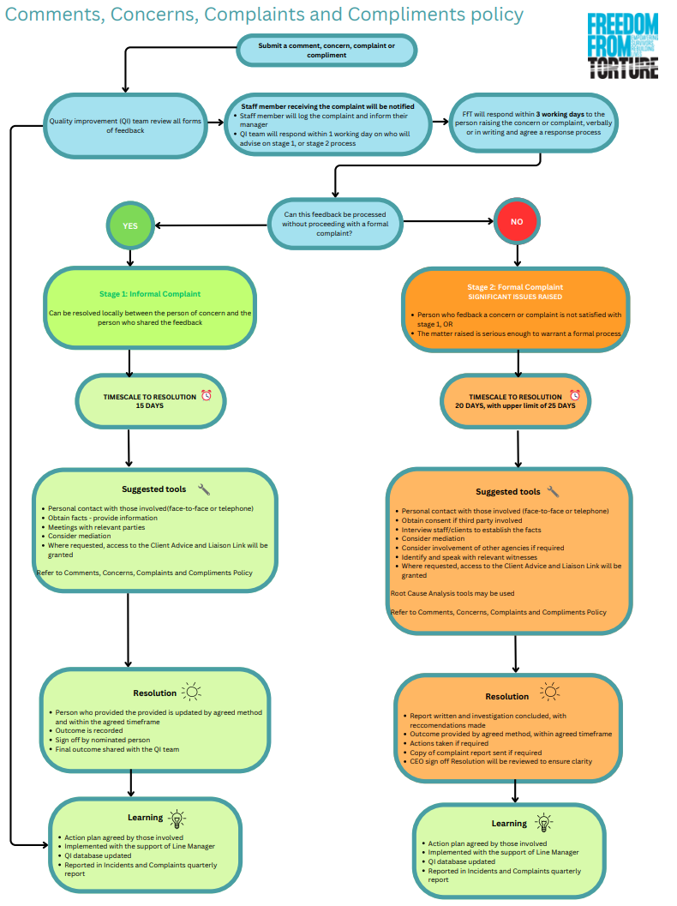

Appendix 2

Comments, Concerns, Complaints and Compliments Log

Date issue reported | MFID (if applicable) | Nature of feedback or complaint | Response taken | Date response taken | Further action recommended | Mgr sign/date

